Walk 30 Skenfrith and Garway
Last walked in June 2016

Description. 8 km (4.9 miles). Most of this route is along quiet, narrow, roughish country lanes, little more than farm tracks, amidst the beautiful scenery of the Monnow Valley on the border between Wales and England.
Start. Parking area in front of Skenfrith Castle. Explorer Map 189. Grid 458202.
Directions from Belmont Roundabout (Turn milometer to zero). Take the A49 to Ross-on-Wye. After 4.5 miles TR onto A466 towards Monmouth. When milometer is on 11.2 miles TR onto the B4521 to Abergavenny/Skenfrith 3. At Skenfrith when the milometer is on 14.1 miles TR to park by Skenfrith the castle.

1. Skenfrith. Skenfrith is a typical border village with a border castle and a border church. The castle is one of the ‘Trilateral’ castles built by Hubert de Burgh in the 13th century to protect the Monnow Valley. It is a simple but striking building, comprising a curtain wall and four rounded towers, within which are the remains of a rare circular keep. The tiny village comprises little more than a row of cottages along the lane beside the castle, which leads to Skenfrith's other gem: the 13th-century church, contemporary with the castle and built by the same man. It is an interesting and sturdy-looking building with thick walls and a massive low tower capped by a wooden belfry that doubled up as a dovecote. The tower gives the church an almost fortress-like appearance and was in fact used as a refuge by villagers during times of trouble. Start by walking back to the main road, TL and follow the road past the Bell and around to the left and over the bridge. Take the first turning on the left, at a notice saying ‘Unsuitable for Heavy Goods Vehicles’, and follow this winding lane for a long 1½ mile up to Garway, ignoring any road or footpaths on your right as you ascend.

2. Garway. Just before reaching the village, TR at a wooden sign for Galway Church and continue along a track to the church. Like the church at Skenfrith this is a typical Norman border church with a fortress feel about it and a solid-looking square tower that could serve as a place of refuge. It is unusual both in its history and appearance. Originally it was one of only six churches in England built by the Knights' Templars, on land given to the Order by Henry II in the 12th century. On the dissolution of that Order in 1408 it passed to their rivals, the Knights' Hospitallers. Its appearance is unusual in that the tower is built at an angle to the main body of the church; originally it was detached and it only became joined to the rest of the church in the 17th century. The interior is dominated by the Norman chancel arch. Pass through the churchyard, keeping to the left of the church, and head for the top left hand corner of the churchyard to go through a metal kissing-gate. Head diagonally across the field, uphill and off to the right towards a house in the far corner of the field where there is a footpath sign and another metal kissing gate which you go through. TR along the road and continue to the top of the hill and through the village. At the end of the village, just passed Garway Inn on the left, you TR along the road signposted to Skenfrith and Abergavenny.
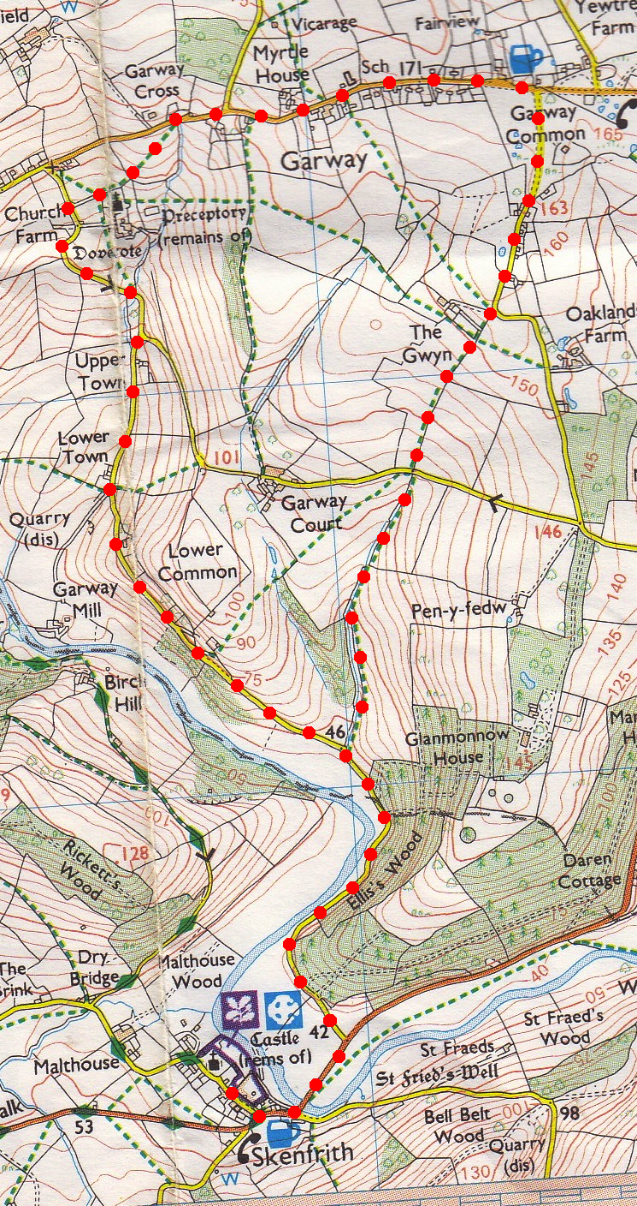
3. Garway Common. Cross the relatively small but open expanse of Garway Common, from which there are fine views all around. Follow this road and when it bends sharply left go straight ahead through a metal gate with a sign ‘Beechland’, then through a wooden gate and head for the left hand side of two garages attached to a house. Continue on past the garages, ignoring a stile on your left, and carry on past an out building keeping a hedge/tree line on your left. Keep on down hill with a hedge/tree line on your left to reach the end of the field where you go through a gate and onto a road. Go straight across the road to cross over a stile into a field.
2
3

4. Downhill. Head downhill along the right-hand edge of a field, keep a wire fence/line of trees on the right. Cross a stile into a larger field and continue downhill keeping the fence/line of trees on your right. Climb a stile at the bottom end of the field and TL along the road, rejoining the outward route. Retrace your steps to Skenfrith and towards the end there are attractive views to the right of both the castle and church across the meadows bordering the Monnow.
4

1
1

